Public Notice
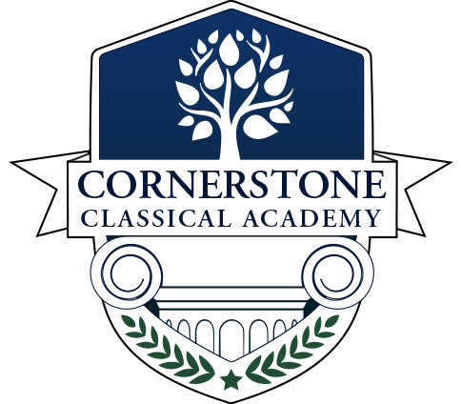
Audit & Financial Oversight Committee Meeting
Cornerstone Classical Academy
Agenda

Call to Order & Roll Call

Reading of the Mission Statement

Agenda Approval

Public Comments

Reports

Unfinished Business

New Business

Adjourn

Meeting Details

When: June 28, 2021, 5:30PM

Where: Virtual Location: meet.google.com/pra-fnry-fjy
(US‬)+1 402-859-0262‬, PIN: 667 251 432#‬‬‬‬

Who: This meeting is open to the public and will include discussion regarding matters pertaining to Cornerstone Classical Academy

Public Comments: All public comment requests must be emailed to the board Treasurer, Chris Engl, with your name and address within 2 hours or more of the meeting to cengl@cornerstoneclassicalacademy.org

